**OBJECTIVE: ---**

**RADHA ECOMMERS SALES DASHBOARD**

Owner of RADHA Store wants us to help them create a dashboard to track and analyze their online sales across India.



**DASHBOARD: ---**

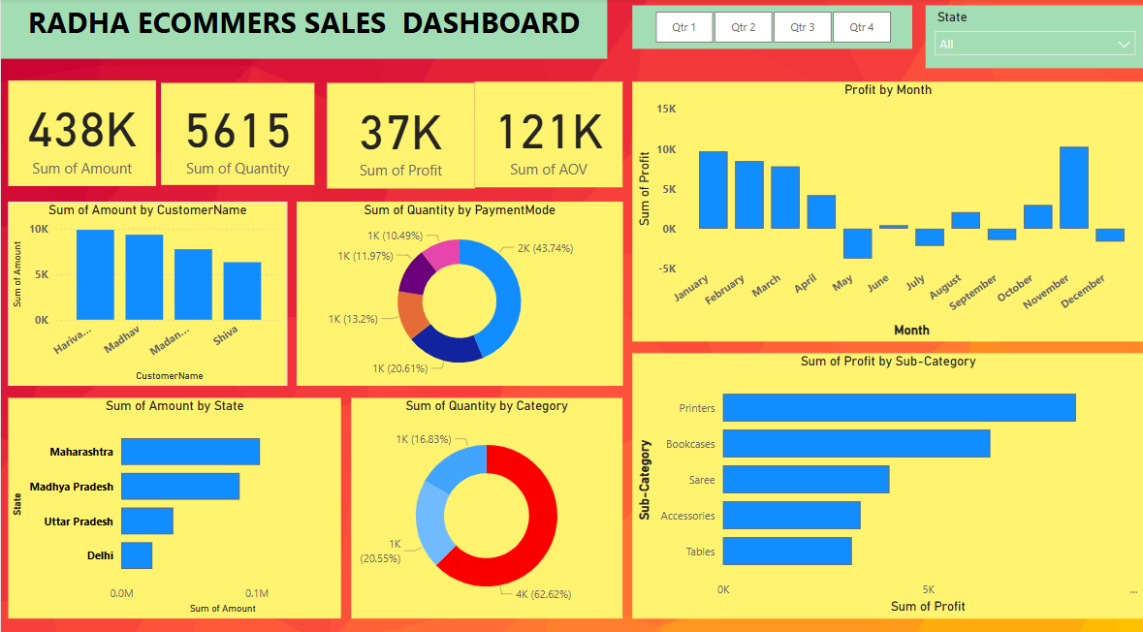

**1. Enhance Targeted Marketing**

**Suggestions to Improve Sales** 🚀

* Use **regional insights** to focus on high-performing states like Maharashtra, Uttar Pradesh, and Madhya Pradesh.
* **Action:** Customize promotions for cities with high demand, such as Mumbai and Indore.

**2. Improve Customer Retention Strategies**

* Frequent orders from specific customers indicate potential for loyalty programs.
* **Action:** Implement personalized discounts and exclusive offers for repeat buyers.

**3. Optimize Inventory Management**

* Ensure high-demand cities have sufficient stock to avoid missed sales.
* **Action:** Utilize predictive analytics to adjust inventory based on historical trends.

**4. Leverage Seasonal Trends**

* Orders peak in **December & January**, suggesting strong holiday demand.
* **Action:** Plan discounts and inventory around seasonal trends to maximize revenue.

**5. Diversify Payment Options**

* Offer **Buy Now, Pay Later (BNPL)** or **EMI-based transactions** to increase affordability.
* **Action:** Encourage digital payments by providing cashback or rewards.

**6. Improve Sales Funnel Efficiency**

* Track order trends to identify bottlenecks in customer conversions.
* **Action:** Streamline checkout processes and reduce friction in online purchases.